Village of Newtown | Board of Zoning Appeals
Regular Meeting
June 18, 2026 | 6:00pm
AGENDA
1. Call to Order
2. Roll Call
3. Guests and Residents
4. Old Business
5. New Business

BZA26-001: Applicant, Nicholas Foster is requesting a variance to exceed the maximum permitted size for an
accessory structure to allow for the installation of a 960 sq. ft. detached garage in the rear yard of the property
located at 3211 Harriet Lane, pursuant to Newtown Zoning Code Section 6.2.D regarding maximum size
and coverage for accessory structures.
6. Village Report
7. Approval of Minutes
8. Adjournment
VILLAGE OF NEWTOWN
3537 Church Street Newtown, OH 45244
June 18, 2026 To:
From:

Village of Newtown Board of Zoning Appeals
Andy Juengling, AICP Planner
Case Number: BZA26-001
Location: 3211 Harriet Lane, Newtown, OH 45244 (Parcel: 050100080113) Existing Zoning: “R-SF,” Residential, Single-Family
Applicant: Anchor Property Management
Owner: Little Miami Real Estate c/o Anchor Property Management
Request: Applicant, Nicholas Foster, is requesting a variance to exceed the maximum permitted size for an accessory structure to allow for the installation of a 960 sq. ft. detached garage in the rear yard of the property located at 3211 Harriet Lane, pursuant to Newtown Zoning Code Section 6.2.D regarding maximum size and coverage for accessory structures.
Project Summary:
The applicant, Nicholas Foster is requesting a variance to exceed the maximum allowable size for an accessory structure (detached storage garage) in the rear yard of the property located at 3211 Harriet Lane within the R-SF, Residential, Single-Family zoning district. The subject property is approximately 14,110 sq. ft. The applicant is proposing to remove the existing storage structure to install a 960 sq. ft. accessory storage garage structure in the rear yard. Section 6.2.D. of the Village of Newtown Zoning Code establishes the following requirements for accessory structures within the R-SF zoning district:
6.2.D. Required Yard Requirements
1. Accessory buildings which are not a part of the main building may be built in a rear yard provided that they are not less than three feet from the rear and side lot lines. A maximum of two accessory buildings are permitted, which in combination shall not occupy more than 30 percent of the required rear yard, shall not exceed the size or area of the principal structure, or 600 square feet (whichever is less) and shall be located at least 60 feet away from any front lot line, except as provided elsewhere by this code.
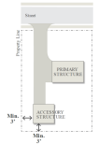
Figure from 6.2.D.1
The principal structure on the subject property (primary residence) has a footprint that measures approximately 1,985 sq. ft. Under the provision of Section 6.2.D.1, the maximum allowable size for accessory structures on the subject property would then be 600 sq. ft as this is less. The applicant is proposing a 960 sq. ft. (24’W x 40’D x 15’H) accessory structure with a proposed set back of 4’ from the south (side) property line and 4’ from the west (rear)
Planning Commission | PC2026-002 3607 Church Street – Zoning Text Amendment
property line which meets the minimum required 3’ setback minimum requirement. The applicant intends to use the structure for personal automobile repair and storage of personal items.
Variance Review Standards
10.06.G. Variances
1. Standard
No such variance of the provisions or requirements of this Zoning Code shall be authorized by the BZA unless the BZA finds that any of the following facts and conditions exist:
a. Exceptional Circumstances
Where, by reason of the exceptional narrowness, shallowness, or unusual shape of a specific piece of property on the effective date of this Zoning Code, or by reason of exceptional topographic conditions, or other extraordinary situation or condition of such piece of property, or of the use or development of property immediately adjoining the piece of property in question, there are exceptional or extraordinary circumstances or conditions applying to the property in question or to the intended use of the property, that do not apply generally to other properties or classes of uses on the same zoning district.
Applicant Response: “Exceptional circumstances are car storage since the garage on the house isn’t deep enough or tall enough for automotive lift for my hobby of working on
personal cars. Also would aid in storage in other personal items”
Staff Findings: The subject property has relatively flat topography and is not unlike other lots in the immediate vicinity. The provisions of Section 6.2.D allow for a 600 square foot
accessory structure, which the applicant would be able to install without the need for any variance request.
b. Preservation of Property Rights
That such variance is necessary for the preservation and enjoyment of substantial property rights which are possessed by other properties in the same zoning district and in the same vicinity.
Applicant Response: “The variance is needed so I can use and enjoy the property in a way similar to neighboring property owners with detached garages from their houses.”
Staff Findings: The provisions of Section 6.2.D establishing a maximum accessory
structure size of 600 sq. ft. applies to all properties within the vicinity, and all properties in an R-SF zoning district village-wide. The applicant indicates that the variance is needed to be able to use the structure for a personal hobby and this is the purpose behind the
request for an additional 360 sq. ft. of area beyond what is permitted by current zoning
regulations.
c. Absence of Detriment
That the authorizing of such variance will not be of substantial detriment to adjacent property and will not materially impair the purposes of this Zoning Code or the public interest.
Applicant Response: “Will not interfere with neighbors access or create any safety
issues. If anything it will add to property values or be an eyesore to the neighborhood.”
Staff Findings: While the variance is substantial at 60%, many properties in the
immediate vicinity have accessory structures of various sizes. However, any proposed
accessory structure shall be reviewed based upon the applicable standards in the current Zoning Code.
d. Not of General Nature
That the condition or situation of the subject property, or the intended use of the property, for which
Village of Newtown | 2
Planning Commission | PC2026-002 3607 Church Street – Zoning Text Amendment
variance is sought, is not of so general or recurrent a nature as to make reasonably practical the formulation of a general regulations for such conditions or situation.
Applicant Response: “Many properties have the same problem, older homes with
smaller garages that don’t accommodate today’s vehicles and should be able to ask for a granting individual variances for zoning.”
Staff Findings: The request for an additional 360 sq ft of floor area for the accessory
structure is not unique to the subject property and would apply to all properties in the R
SF zoning district in the Village of Newtown.
Optional Motions
Option 1: Motion to APPROVE
Move to approve BZA26-001 regarding a variance request to exceed the maximum permitted size for an accessory structure based on the following findings:
1. _____________________________________________________________________________; 2. _____________________________________________________________________________;
Option 2: Motion to APPROVAL WITH MODIFICATIONS
Move to approve BZA26-001 regarding a variance request to exceed the maximum permitted size for an accessory structure with the following modifications
1. _____________________________________________________________________________;
Based on the following findings:
1. _____________________________________________________________________________; 2. _____________________________________________________________________________;
Option 3: Motion to TABLE
Move to table BZA26-001 regarding a variance request to exceed the maximum permitted size for an accessory structure until the next scheduled Board of Zoning Appeals meeting in order to: 1. _____________________________________________________________________________; 2. _____________________________________________________________________________;
Option 4: Motion to DENY
Motion to deny BZA26-001 regarding a variance request to exceed the maximum permitted size for an accessory structure based on the following findings:
1. _____________________________________________________________________________; 2. _____________________________________________________________________________;
Village of Newtown | 3
6919
⁶⁹³⁴₆₉₄₀ 6936
⁶⁹⁵⁰ 6952
6954
6956
6921
7010
6925
RA^{G}LA^{N}D RD
6927
6935
3213
6937
6939
6941
₆₉₄₅ 6943 3214
7014
3130
3200
R-SF
Residential Single Family
3211
3209
3205
3205
_{HARRIET L}N
3202
3212
3210
3208
3206
Microsoft, Vantor
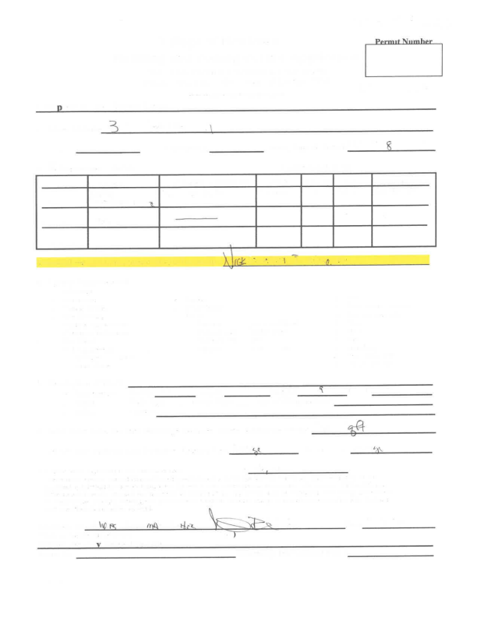

Outlook
Re: 3213 Harriet Accessory Structure
From Nick Foster <nickfoster01@yahoo.com>
Date Thu 06/11/2026 10:43 AM
To Andy Juengling <ajuengling@villageofnewtown.com>
Yeah the shed will be moved off the property
Sent from my iPhone
On Jun 11, 2026, at 10:37 AM, Andy Juengling <ajuengling@villageofnewtown.com> wrote:
Nick, is the existing structure on the property being replaced by this proposal, or is the structure there the one being requested?
Andy Juengling, AICP | LEED GA
Planner
Village of Newtown
3537 Church Street
Newtown, OH 45244
ajuengling@villageofnewtown.com | 513.272.9112
From: Nick Foster <nickfoster01@yahoo.com>
Sent: Tuesday, June 02, 2026 8:36 PM
To: Andy Juengling <ajuengling@villageofnewtown.com>
Subject: Re: 3213 Harriet Accessory Structure
G. -building a detached garage for car storage
1- standard
a- exceptional circumstances are car storage since the garage on the house isn’t deep enough or tall enough for automotive lift for my hobby of working on personal cars.
Also would aid in storage in other personal items
1-b. The variance is needed so I can use and enjoy the property in a way similar to neighboring property owners with detached garages from their houses
1-c. Will not interfere with neighbors access or Crete any safety issues. If anything it will add to property values or be an eyesore to the neighborhood. 1-d. many properties have the same problem, older homes with smaller garages that don’t accommodate today’s vehicles and should be able to ask for a granting individual variances for zoning
2-a.
nicholas Lee Broerman foster
3211 harriet ln cincinnati ohio 45244
513-545-1183 cell phone
2-b. Home living and hobby automotive use/tinkering
2-c. Location rear left side, 50101-Newtown 01
Parcel id 501-0008-0113-00
2-d. single family dwelling
2-e. Detached 24x40x10 garage 4ft from both property lines on the back left corner of the lot for extra car storage
2-f. plans on paperwork already.
2-g. Please let me know about the information
2-h.
3213 harriet ln cincinnati ohio 45244
FOSTER NICHOLAS BROERMAN & CONSTANCE DEVRIES
501-0008-0112-00
3209 harriet ln cincinnati ohio 45244
ALSPAUGH JAMES M
501-0008-0114-00
3200 Newtown rd cincinnati ohio 45244
YEAGER HARVEY DAVID
501-0008-0129-00
Please by all means let me know if I’ve messed anything up since I don’t do this everyday and I can get them resolved, Thanks again for your help!
Sent from my iPhone
On Jun 2, 2026, at 3:33 PM, Andy Juengling
<ajuengling@villageofnewtown.com> wrote:
Nick,
Could you please complete the responses to the attached Section 10.7.G.1 (highlighted in the attached pdf)? We will need this in order to continue to proceed with this application for the June 18th BZA meeting.
Thanks,
Andy Juengling, AICP | LEED GA
Planner
Village of Newtown
3537 Church Street
Newtown, OH 45244
ajuengling@villageofnewtown.com | 513.272.9112
From: Andy Juengling <ajuengling@villageofnewtown.com> Sent: Friday, May 01, 2026 9:03 AM
To: Nick Foster <nickfoster01@yahoo.com>
Subject: Re: 3213 Harriet Accessory Structure
Nick,
Sorry for the delayed response! This week has been insane, so my apologies and thank you for your patience!
As you mentioned, the proposed detached garage exceeds the maximum allowed square footage for accessory structures, and it also exceeds the 30% maximum coverage of the rear yard. The plans do not indicate setbacks or building height, so I can't determine if these items need variances as well. However, based on the current plans, we would not be able to proceed in issuing a permit. The only course would be to revise your plans to meet the requirements or seek a variance through the Board of Zoning Appeals, as you mentioned.
I have attached the application for the BZA. Along with the application, we will need the site plan you submitted with proposed setbacks from each property line and the existing single-family home on the property. We will also need any elevations or additional drawings you have for the structure.
I have attached the section of the Zoning Code that pertains to variances. Note that Section 10.7.G.1. Variance - Standards has four (4) facts and conditions that each variance is reviewed upon. Please respond to each of these and include as part of the application.
Additionally, the items listed in Section 10.7.G.2. Application for Appeal or Variance needs to be included as part of the application.
I have an email out to the BZA members to confirm availability for a meeting, but we are at this point targeting Tuesday, May 26th or Wednesday, May 27th. Do these dates work for you? I have to have notices out at least 20 days prior to the meeting, so they
need to be sent Tuesday or Wednesday of next week. If you can confirm, I will act accordingly.
Thanks,
Andy Juengling, AICP | LEED GA
Planner
Village of Newtown
3537 Church Street
Newtown, OH 45244
ajuengling@villageofnewtown.com | 513.272.9112
From: Nick Foster <nickfoster01@yahoo.com>
Sent: Sunday, April 26, 2026 6:24 PM
To: Andy Juengling <ajuengling@villageofnewtown.com> Subject: Re: 3213 Harriet Accessory Structure
Hey, sorry to keep masking questions but is there any options to possibly make it bigger like 24x36? Like how do I go about asking for a zoning variance? If not a bigger foot print, possibly go higher than 15 feet for a second story for storage?
Hope you had a good weekend. Please let me know if it’s an a possibility
Thanks!
Sent from my iPhone
On Apr 24, 2026, at 3:41 PM, Andy Juengling
<ajuengling@villageofnewtown.com> wrote:
Maximum height for accessory structures if 15'
Andy Juengling, AICP | LEED GA
Planner
Village of Newtown
3537 Church Street
Newtown, OH 45244
ajuengling@villageofnewtown.com | 513.272.9112
From: Nick Foster <nickfoster01@yahoo.com> Sent: Thursday, April 23, 2026 5:29 PM
To: Andy Juengling <ajuengling@villageofnewtown.com> Subject: Re: 3213 Harriet Accessory Structure
Awesome thank you, do you happen to know how tall the building can be?
Sent from my iPhone
On Apr 23, 2026, at 3:15 PM, Andy Juengling <ajuengling@villageofnewtown.com> wrote:
Nick,
Taking a look at your property, below is an image showing where a detached garage could be located. The garage would also need to meet the following:
Be located within the area designated as "rear
yard",
Be at least 3' from the south and west property
line,
Be at least 60 feet from the north property line
Occupy no more than 30% of the rear yard, or 600
square feet, whichever is less.
<image.png>
Once you know the location, you will want to mark on a site plan the proposed location, size, dimensions, and setbacks from property lines and the home. Attached is a copy of the zoning permit application. You will
complete the application and file it with the village offices in the address below my signature with Becky Fairley (copied on this email). The permit fee is $50 and is due at time of submittal.
If you have any questions, let me know.
Thanks,
Andy Juengling, AICP | LEED GA
Planner
Village of Newtown
3537 Church Street
Newtown, OH 45244

