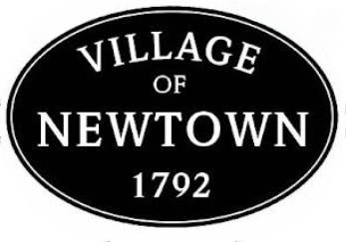
Council Meeting Agenda – June 9, 2026
- Call to Order/Pledge of Allegiance/Attendance

- Approval of the 05.12.2026 Regularly-Scheduled Council Minutes

3. Special Presentations
- Engineering Report submitted by Verdantas, previously CT Consultants
4. Audience Participation (3 Minute Limit)

5. Mayor’s Report
- Recognition of Lieutenant Shawn McBreen – 25 Years of Dedication and Loyalty
- Summerfest (confirming date/time/location, approving the band
- Approve contract for music for Summerfest
- Rumpke Proposal

6. Council Member Reports
- Maintenance Report – Mr. Fairley
- Spending Limit Increase
- Ivy Hills Culvert Clean-out $7500
- Finance Committee 5/17/2026 Report – Mr. Fairley
- Safety Services Reports (ATFD and Newtown Police Department) – Mr. Schwab
- Finance Report/February 2026 Budget – Mr. Thompson
- Planning Commission Update – Mr. Collins
- Parks Committee Update (5/20/2026) – Ms. Donohue
7. Village Solicitor’s Report
8. Legislation
- Ordinance amending the purchasing and procurement policy for the Village of Newtown and Declaring
An Emergency
- Resolution approving an agreement with Axon Enterprise, Inc. for Police Department Equipment
  - Body worn cameras, tasers and related equipment, services/software $87,408.82
- Resolution declaring intent to conduct internet auctions for the sale of unneeded, obsolete, or unfit village personal property
- Resolution declaring certain personal property unneeded, obsolete, or unfit for municipal purposes and authorizing the sale of such property (2015 F-350 truck w/snowplow, VIN 1FTRF3B69FEA71220
- Resolution approving an agreement w/Axon Enterprise, Inc. for police department equipment
- Resolution approving a contract with Evans Landscaping for Creek Dredging at Lake Barber $18,892
9. New Business
- Council Checklist dated 06.09.2026
- Motion approve $7,500 to TeleVac for Ivy Hills Culvert Cleanout
- TIRC annual meeting (7/2/2026) name a second representative as Becky is unable to attend
10. Adjournment

