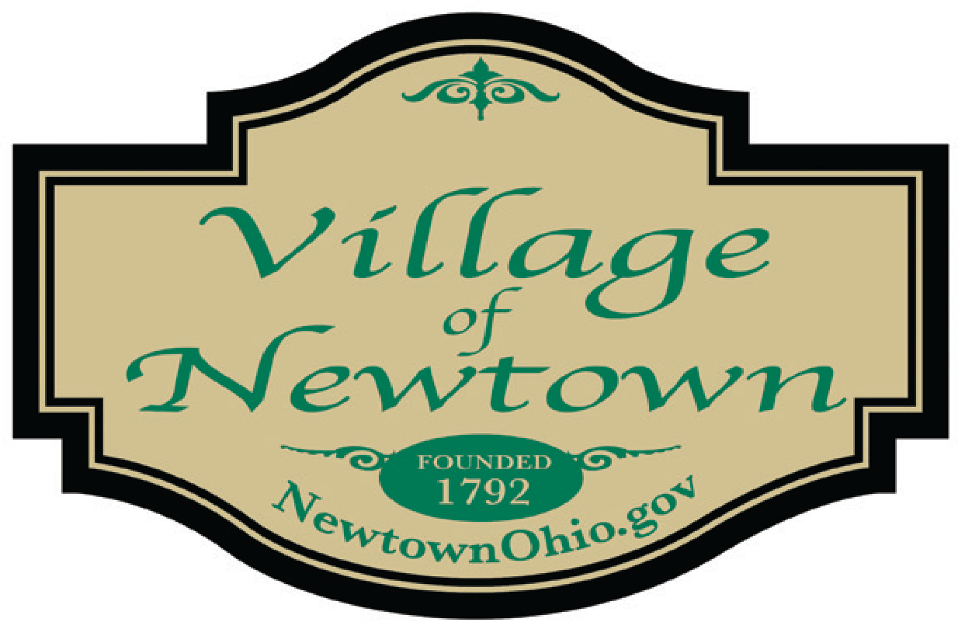

Council Meeting Agenda - March 12, 2024
- Call to Order/Pledge of Allegiance/Attendance

- Approval of the Council Minutes: Regularly Scheduled 02.13.2024 Council Minutes

- Special Presentations

- Anderson Township Fire Chief Rick Martin – Emergency Services Discussion
- Engineering Report submitted by CT Consultants

- Mayor’s Report

- Council Member Reports

- Ohio Division of Liquor Control – Motion to NOT request a hearing for transfer of license
(Lobsta Bakes of Maine Bistro LLC – 3603 Church Street – Mr. Fairley
- Hamilton County Tax Incentive Review Council – Mr. Fairley
    - Two TIRC Representatives need to be appointed to attend the June TIRC meeting.
    - Per the O.R.C. when a community has a TIRC, two members have to be residents of the
community, which can also be a Mayor, Council Member,
or Administrator – Others are welcome to attend that are able to answer questions from the
TIRC Hamilton County Board Members, regarding compliance of the CRA agreements with the businesses.
(In past, Finance Chair, Mayor, Keri or Becky have attended) Keri prepares the
Status Reports from information Becky gathers from businesses
- Motion to accept the January 2024 Finance Packet – Mr. Fairley
- Planning Commission Update – Mr. Schwab
- Board of Health Annual Meeting – Mr. Schwab
- Maintenance Report – Ms. Quallen
- SummerFest – Ms. Boone
- Metro Bus Stop – Ms. Donohue

- Village Solicitor’s Report

- Legislation:
- Final Reading of an Ordinance to make appropriations for current expenses and other
expenditures of the Village of Newtown During the Fiscal Year Ending December 31, 2024
- Ordinance adopting Rules of Council – declaring an emergency
- Ordinance adopting Building Rules for Municipal Bldg and Police Station – declaring an emergency
- Ordinance authorizing the execution of an easement agreement w/SP Property Holdings – declaring an emergency
- Ordinance establishing NO PARKING ZONES w/the River Hills Subdivision
- Resolution amending the Village’s Police Compensation Policy
- Resolution authorizing the Village of Newtown to enter into a Grant Agreement w/the Hamilton County Board of Commissioners related to the McCullough’s Run remediation project
- Resolution authorizing the Village of Newtown to enter into a Grant Agreement w/the Hamilton County Board of Commissioners related to the Round Bottom Stormwater Sewer Improvement project
- Resolution approving a contract w/A & A Lawncare & Landscaping for grounds maintenance services for the Flag Spring Cemetery and the Fire Station lot in the Village of Newtown
- Resolution approving an agreement with Anderson Township Little League, Inc. for use of athletic fields @ Moundview
- Resolution approving a contract w/Debra-Kuempel for HVAC preventative maintenance services $7,751/year

- New Business
- Council Checklist dated 03.12.2024 - $169,101.01 (Mr. Fairley)

- Adjournment

