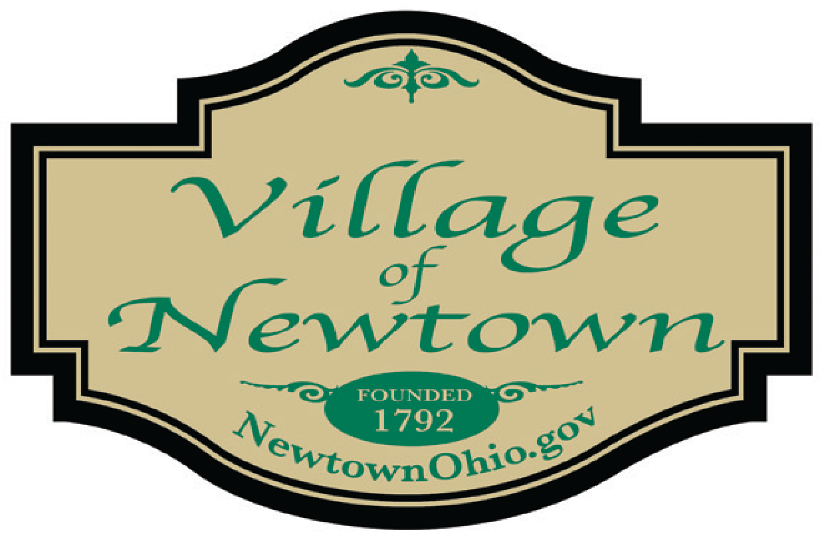

Council Meeting Agenda - January 10, 2023
- Call to Order/Pledge of Allegiance/Attendance

- Approval of the Council Minutes: 012.13.2022

- Special Presentations

- CT Engineering Report – Mr. Short

- Mayor and Council Member Report
Mayor’s Report
- 2023 – Vice Mayor appointment and Council Committees
- 5935 Main Street (Sidewalk)
- ATFD EMT Procedures Meeting held Dec. 16, 2022
- ODOT Meeting held Dec. 16, 2022
- CT Proposal for McCullough’s Run (revised)
Council Member Reports
- Motion to accept the December 2022 Finance Packet (Mr. Fairley)
- ATFD (Mr. Drescher)

- Village Solicitor’s Report

- Legislation:
- An ordinance setting the date, time and place of Village Council Meetings
- An ordinance providing for the employment/compensation of legal counsel
- An ordinance approving supplemental appropriations and transfers for 2022 & reconciling
The budget and amending appropriations for calendar year 2022
- A resolution approving a contract for liability insurance w/The Ohio Plan Risk Management

- New Business

- Council Checklist dated 01.10.2023 ($188,624.96)

- Adjournment

