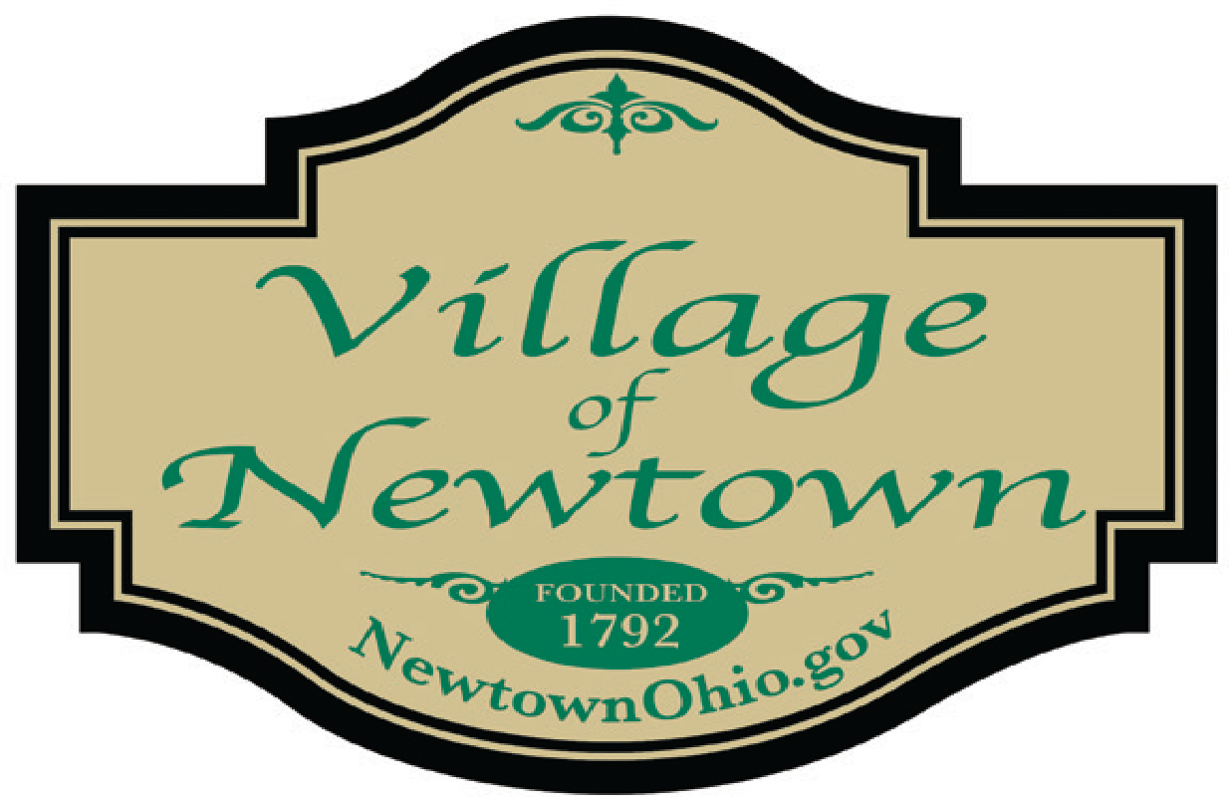

Council Meeting Agenda - December 13, 2022
- Call to Order/Pledge of Allegiance/Attendance

- Approval of the Council Minutes: 011.08.2022

- Special Presentations

- Hamilton County R3Source, 15-year Hamilton County Solid Waste Plan
- CT Engineering Report – Mr. Short

- Public Comments/Participation (Participants must sign-in) (Two Minute Limit)
- Mayor and Council Member Report
Mayor’s Report
- ATFD EMT Procedures Meeting December 16th at 10am
- ODOT Meeting December 16th at 1pm
- Street Pavement Condition Study $12,000 – CT Consultants
Council Member Reports
- Motion to accept the November 2022 Finance Packet

- Village Solicitor’s Report

- Legislation:
- An ordinance approving temporary appropriations for the expenses and other expenditures of the
Village of Newtown for Fiscal Year 2023
- A resolution approving a Health Reimbursement Arrangement for eligible Village employees
- A resolution approving contracts for employee health, dental, vision and life insurance
- A resolution approving a contract w/Mark A. Yontz for professional services
- A resolution approving a revised estimate for engineering services related to the Short Park
Parking lot paving and expansion project

- New Business

- Council Checklist dated 12.13.2022 ($578,110.61)

- Adjournment

